**Spring 2022 CMPE 202 – Software Systems Engineering – Individual Project**

**Name – Kusuma Padma Kavya Bandi**

**SJSU ID – 016021785**

**Positive test case 1**

**a. Amount is calculated based on input items and quantities**

**b. When a new card is used to place the order, the respective card number is updated in the database**

Existing Cards

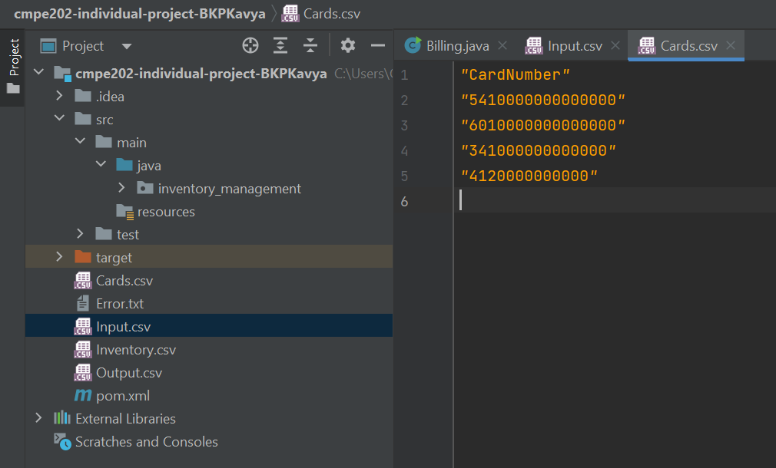

Input

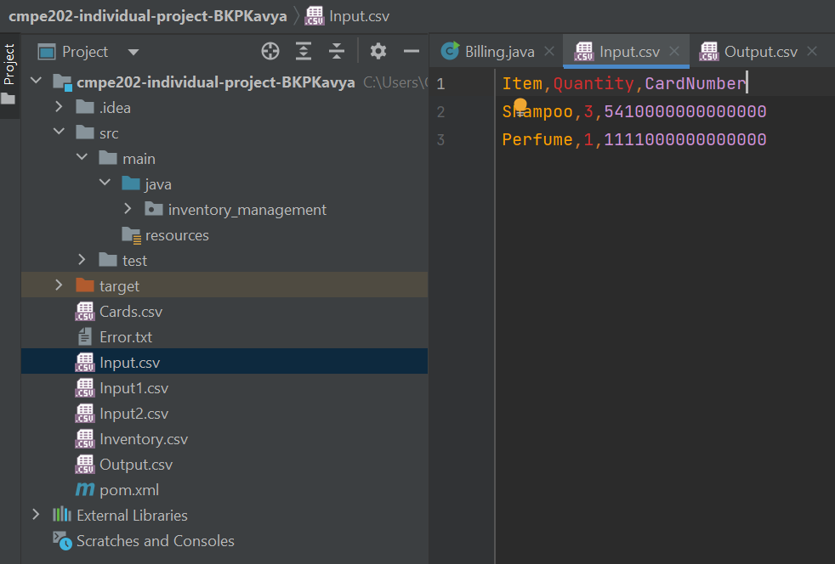

Output (Shampoo 3*10 + Perfume 1*50 = 80)

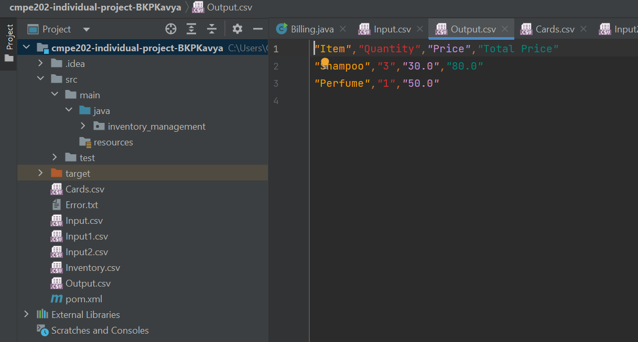

Updated Cards

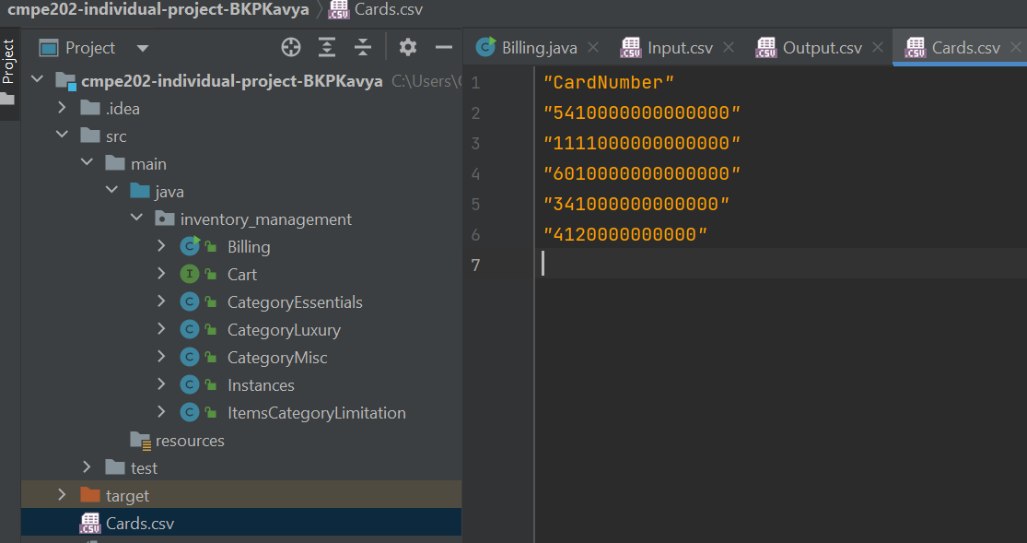

**Negative test case (When essential item quantity is inputted more than permissible)**

**Note: Negative test cases are when the user inputs more than permissible quantities for items based on their categories i.e. essentials >3, luxury>4, and misc>6.**

Input

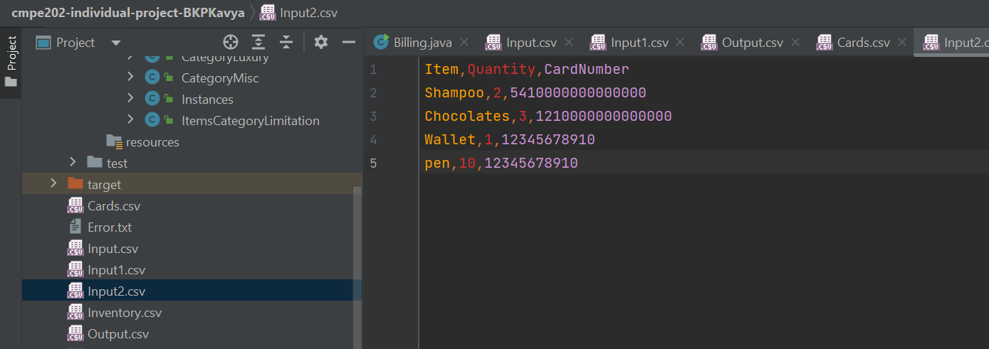

Error

